2. spring-rest-handson
HandsOn_1. HTTP Request Response
What is HTTP?
HTTP (Hypertext Transfer Protocol) is a stateless protocol that defines how requests and responses are exchanged between a client (e.g., browser) and a server over the web.

Sample HTTP Request
GET /hello.txt HTTP/1.1
User-Agent: curl/7.16.3 libcurl/7.16.3 OpenSSL/0.9.7l zlib/1.2.3
Host: www.example.com
Accept-Language: en, mi
Explanation of Request Lines
Line | Description
GET /hello.txt HTTP/1.1 | Method: GET (used to fetch data), Resource path: /hello.txt, HTTP version: HTTP/1.1
User-Agent: curl/... | Identifies the client application making the request
Host: www.example.com | Specifies the server domain
Accept-Language: en, mi | Indicates preferred languages for the response

Sample HTTP Response
HTTP/1.1 200 OK
Date: Mon, 27 Jul 2009 12:28:53 GMT
Server: Apache
Last-Modified: Wed, 22 Jul 2009 19:15:56 GMT
ETag: "34aa387-d-1568eb00"
Accept-Ranges: bytes
Content-Length: 51
Vary: Accept-Encoding
Content-Type: text/plain
Hello World! My payload includes a trailing CRLF.
Explanation of Response Lines
Line | Description
HTTP/1.1 200 OK | HTTP version: HTTP/1.1, Status code: 200 (OK - success)
Date | Timestamp when the server processed the request
Server | Server software used (e.g., Apache)
Last-Modified | Date and time when the resource was last modified
ETag | Identifier used for cache validation
Accept-Ranges: bytes | Supports partial downloads or streaming
Content-Length: 51 | Size of the response body in bytes
Content-Type: text/plain | MIME type of the response (plain text in this case)
Response Body | Actual data sent by the server ("Hello World!..." in plain text)

Common Content-Type Values
Content-Type | Description
text/plain | Plain text content
text/html | HTML document
application/json | JSON formatted data
image/png | PNG image file

Viewing HTTP Request/Response in Chrome
Steps to view live HTTP traffic using Chrome Developer Tools:
- Open Chrome.
- Press F12 to launch Developer Tools.
- Navigate to the Network tab.
- Open any website (e.g., google.com).
- Select any request from the list.
- Examine the following tabs:
  - General: Summary including status code and URL.
  - Request Headers: Data sent from browser to server.
  - Response Headers: Data received from server.

Additional Notes
- The URL entered in the browser is split into Host (domain) and Resource (path).
- The actual HTTP message (both request and response) is a plain text message sent over TCP.
- The GET method is just one of several HTTP methods, others include POST, PUT, DELETE, etc.
- Content-Type determines how the browser should interpret or render the returned data.
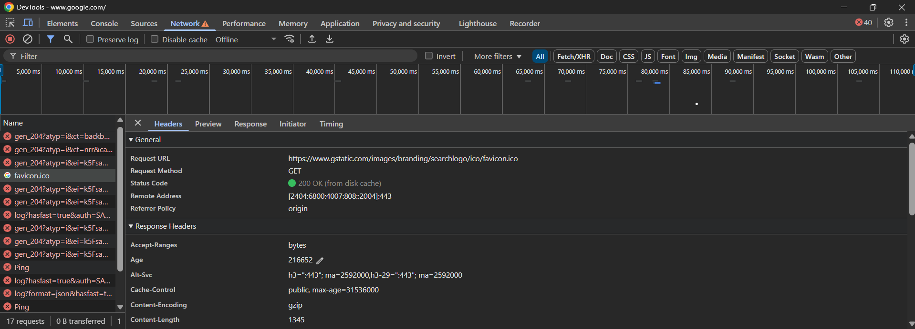

HandsOn_2. Hello World RESTful Web Service
HelloController.java
package com.cognizant.hello_rest.controller;

import org.slf4j.Logger;
import org.slf4j.LoggerFactory;
import org.springframework.web.bind.annotation.*;

@RestController
public class HelloController {

private static final Logger LOGGER = LoggerFactory.getLogger(HelloController.class);

@GetMapping("/hello")
public String sayHello() {
LOGGER.info("START sayHello()");
String message = "Hello World!!";
LOGGER.info("END sayHello()");
return message;
}
}
HelloRestApplication.java
package com.cognizant.hello_rest;

import org.springframework.boot.SpringApplication;
import org.springframework.boot.autoconfigure.SpringBootApplication;

@SpringBootApplication
public class HelloRestApplication {

public static void main(String[] args) {
SpringApplication.run(HelloRestApplication.class, args);
}
}

application.properties
spring.application.name=code
server.port=8083
CodeApplicationTests.java
package com.cognizant.hello_rest;

import org.junit.jupiter.api.Test;
import org.springframework.boot.test.context.SpringBootTest;

@SpringBootTest
class CodeApplicationTests {

@Test
void contextLoads() {
}

}
HelloRestApplicationTests.java
package com.cognizant.hello_rest;

import static org.springframework.test.web.servlet.request.MockMvcRequestBuilders.get;
import static org.springframework.test.web.servlet.result.MockMvcResultMatchers.*;

import org.junit.jupiter.api.Test;
import org.springframework.beans.factory.annotation.Autowired;
import org.springframework.boot.test.autoconfigure.web.servlet.AutoConfigureMockMvc;
import org.springframework.boot.test.context.SpringBootTest;
import org.springframework.test.web.servlet.MockMvc;

@SpringBootTest
@AutoConfigureMockMvc
public class HelloRestApplicationTests {

@Autowired
private MockMvc mockMvc;

@Test
public void testSayHello() throws Exception {
mockMvc.perform(get("/hello"))
.andExpect(status().isOk())
.andExpect(content().string("Hello World!!"));
}
}
OUTPUT
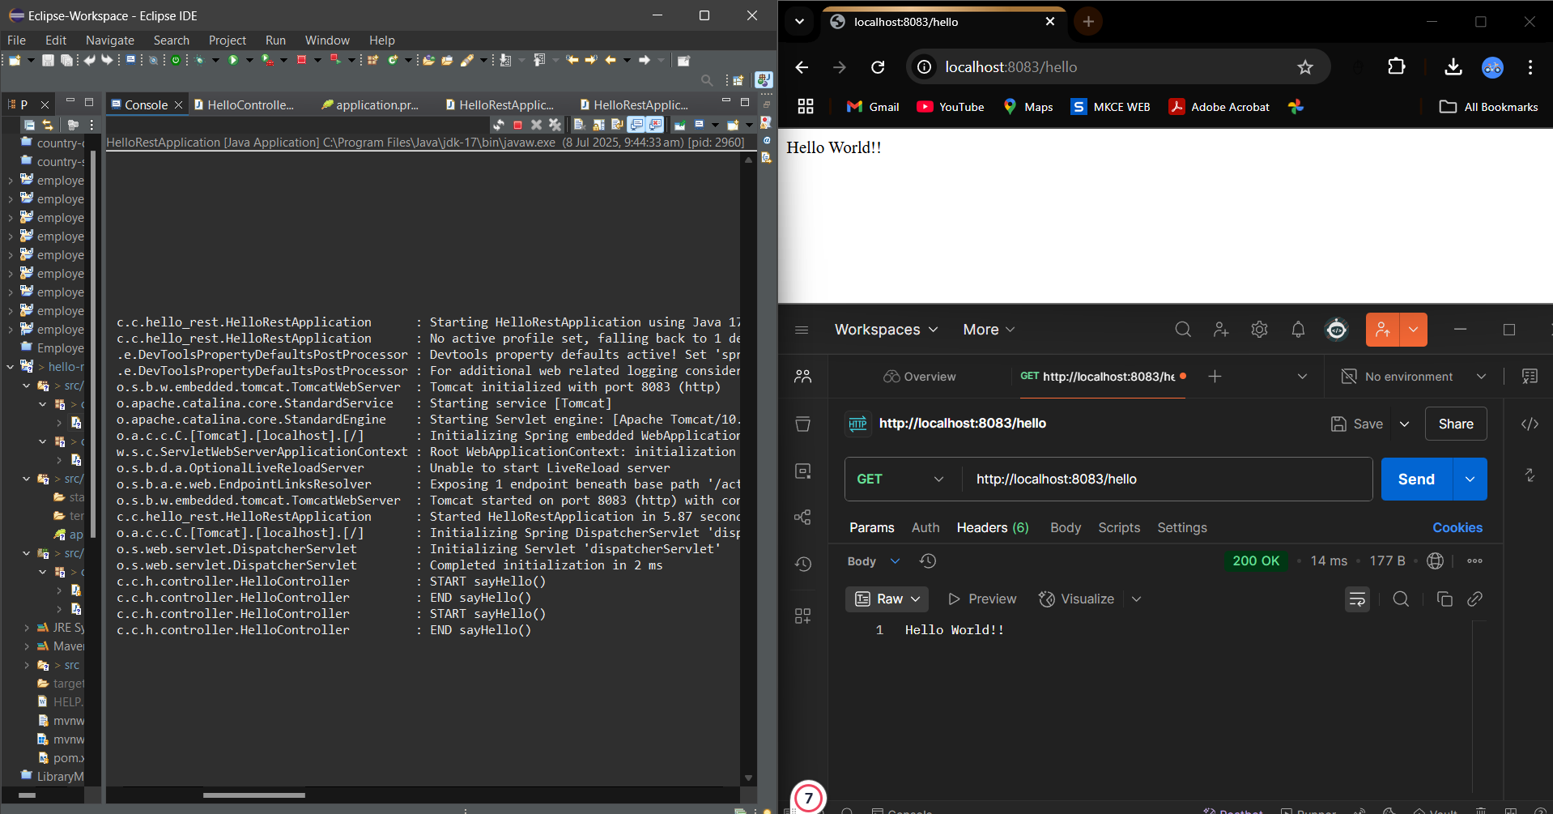

HandsOn_3. REST - Country Web Service
CountryController.java
package com.cognizant.country_rest_service.controller;

import com.cognizant.country_rest_service.model.Country;
import org.slf4j.Logger;
import org.slf4j.LoggerFactory;
import org.springframework.context.ApplicationContext;
import org.springframework.context.support.ClassPathXmlApplicationContext;
import org.springframework.web.bind.annotation.RequestMapping;
import org.springframework.web.bind.annotation.RestController;

@RestController
public class CountryController {

private static final Logger LOGGER = LoggerFactory.getLogger(CountryController.class);

@RequestMapping("/country")
public Country getCountryIndia() {
LOGGER.info("START");

ApplicationContext context = new ClassPathXmlApplicationContext("country.xml");
Country country = (Country) context.getBean("in");

LOGGER.debug("Country: {}", country);
LOGGER.info("END");
return country;
}
}
Country.java
package com.cognizant.country_rest_service.model;

import org.slf4j.Logger;
import org.slf4j.LoggerFactory;

public class Country {

private static final Logger LOGGER = LoggerFactory.getLogger(Country.class);

private String code;
private String name;

public Country() {
LOGGER.debug("Inside Country Constructor");
}

public String getCode() {
LOGGER.debug("Getting code");
return code;
}

public void setCode(String code) {
LOGGER.debug("Setting code");
this.code = code;
}

public String getName() {
LOGGER.debug("Getting name");
return name;
}

public void setName(String name) {
LOGGER.debug("Setting name");
this.name = name;
}

@Override
public String toString() {
return "Country [code=" + code + ", name=" + name + "]";
}
}
RestCountryApplication.java
package com.cognizant.country_rest_service;

import org.slf4j.Logger;
import org.slf4j.LoggerFactory;
import org.springframework.boot.SpringApplication;
import org.springframework.boot.autoconfigure.SpringBootApplication;

@SpringBootApplication
public class RestCountryApplication {

private static final Logger LOGGER = LoggerFactory.getLogger(RestCountryApplication.class);

public static void main(String[] args) {
LOGGER.info("START");
SpringApplication.run(RestCountryApplication.class, args);
LOGGER.info("END");
}
}
application.properties
spring.application.name=code
server.port=8088
logging.level.com.cognizant=debug
country.xml
<?xml version="1.0" encoding="UTF-8"?>
<beans xmlns="http://www.springframework.org/schema/beans"
xmlns:xsi="http://www.w3.org/2001/XMLSchema-instance"
xsi:schemaLocation="http://www.springframework.org/schema/beans
http://www.springframework.org/schema/beans/spring-beans.xsd">

<bean id="in" class="com.cognizant.country_rest_service.model.Country">
<property name="code" value="IN"/>
<property name="name" value="India"/>
</bean>

</beans>
CodeApplicationTests.java
package com.cognizant.country_rest_service;

import org.junit.jupiter.api.Test;
import org.springframework.boot.test.context.SpringBootTest;

@SpringBootTest
class CodeApplicationTests {

@Test
void contextLoads() {
}

}
OUTPUT
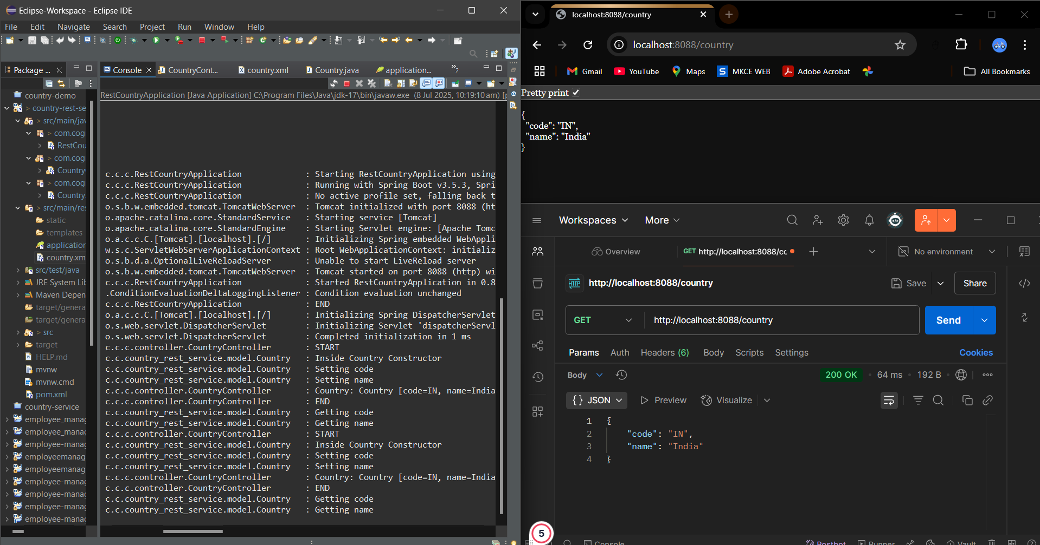
HandsOn_4. REST - Get all countries
CountryController.java
package com.cognizant.country_api.controller;

import com.cognizant.country_api.model.Country;
import org.slf4j.Logger;
import org.slf4j.LoggerFactory;
import org.springframework.context.ApplicationContext;
import org.springframework.context.support.ClassPathXmlApplicationContext;
import org.springframework.web.bind.annotation.GetMapping;
import org.springframework.web.bind.annotation.RestController;

import java.util.List;

@RestController
public class CountryController {

private static final Logger LOGGER = LoggerFactory.getLogger(CountryController.class);

@GetMapping("/countries")
public List<Country> getAllCountries() {
LOGGER.info("START - getAllCountries()");
ApplicationContext context = new ClassPathXmlApplicationContext("country.xml");
List<Country> countries = (List<Country>) context.getBean("countryList");
LOGGER.debug("Countries: {}", countries);
LOGGER.info("END - getAllCountries()");
return countries;
}
}

Country.java
package com.cognizant.country_api.model;

public class Country {
private String code;
private String name;

public Country() {
System.out.println("Inside Country Constructor");
}

public String getCode() {
System.out.println("Getting code");
return code;
}

public void setCode(String code) {
System.out.println("Setting code");
this.code = code;
}

public String getName() {
System.out.println("Getting name");
return name;
}

public void setName(String name) {
System.out.println("Setting name");
this.name = name;
}

@Override
public String toString() {
return "Country{code='" + code + "', name='" + name + "'}";
}
}
CountryApiApplication.java
package com.cognizant.country_api;

import org.springframework.boot.SpringApplication;
import org.springframework.boot.autoconfigure.SpringBootApplication;

@SpringBootApplication
public class CountryApiApplication {
public static void main(String[] args) {
SpringApplication.run(CountryApiApplication.class, args);
}
}
Country.xml
<?xml version="1.0" encoding="UTF-8"?>
<beans xmlns="http://www.springframework.org/schema/beans"
xmlns:xsi="http://www.w3.org/2001/XMLSchema-instance"
xsi:schemaLocation="http://www.springframework.org/schema/beans
https://www.springframework.org/schema/beans/spring-beans.xsd">

<bean id="in" class="com.cognizant.country_api.model.Country">
<property name="code" value="IN"/>
<property name="name" value="India"/>
</bean>

<bean id="us" class="com.cognizant.country_api.model.Country">
<property name="code" value="US"/>
<property name="name" value="United States"/>
</bean>

<bean id="de" class="com.cognizant.country_api.model.Country">
<property name="code" value="DE"/>
<property name="name" value="Germany"/>
</bean>

<bean id="jp" class="com.cognizant.country_api.model.Country">
<property name="code" value="JP"/>
<property name="name" value="Japan"/>
</bean>

<bean id="countryList" class="java.util.ArrayList">
<constructor-arg>
<list>
<ref bean="in"/>
<ref bean="us"/>
<ref bean="de"/>
<ref bean="jp"/>
</list>
</constructor-arg>
</bean>

</beans>
application.properties
spring.application.name=code
server.port=8088
CodeApplicationTests.java
package com.cognizant.country_api;

import org.junit.jupiter.api.Test;
import org.springframework.boot.test.context.SpringBootTest;

@SpringBootTest
class CodeApplicationTests {

@Test
void contextLoads() {
}

}
OUTPUT
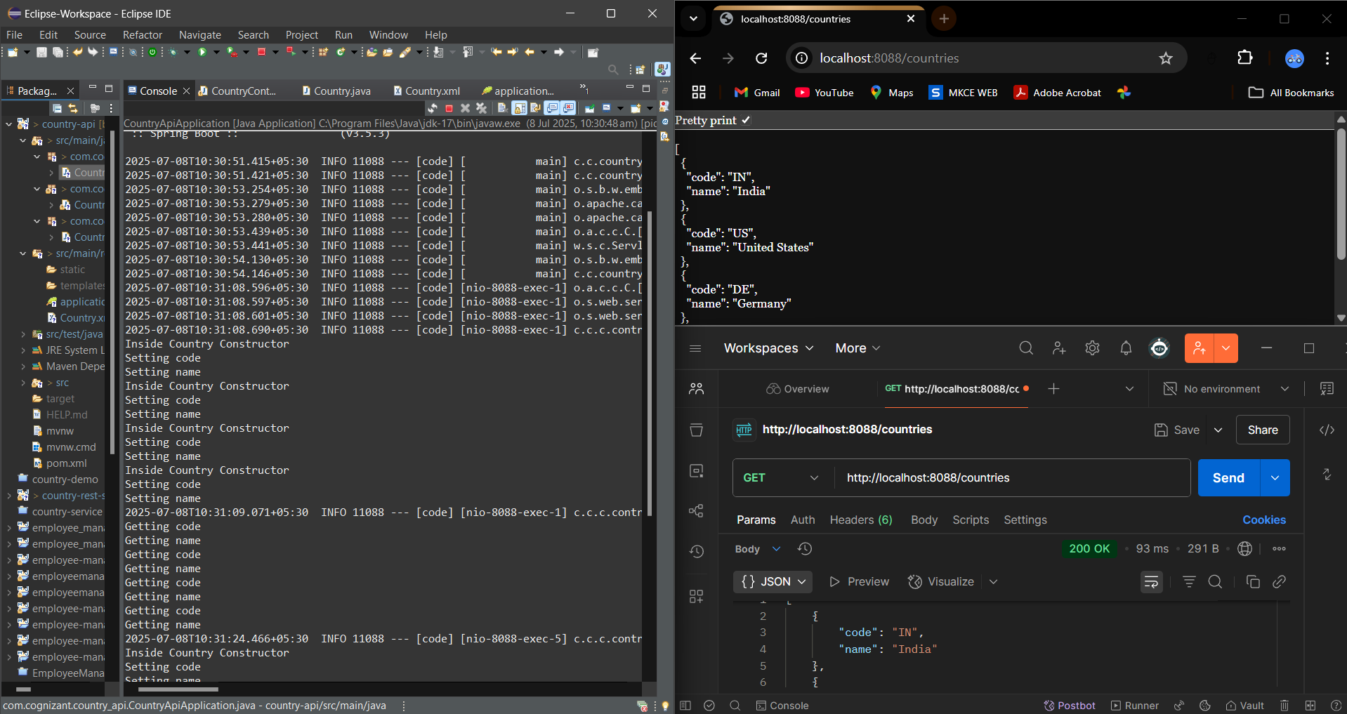
HandsOn_5. REST - Get country based on country code
CountryController.java
package com.cognizant.country_code_api.controller;

import com.cognizant.country_code_api.model.Country;
import com.cognizant.country_code_api.service.CountryService;
import org.springframework.beans.factory.annotation.Autowired;
import org.springframework.web.bind.annotation.*;

@RestController
public class CountryController {

@Autowired
private CountryService countryService;

@GetMapping("/countries/{code}")
public Country getCountry(@PathVariable String code) {
return countryService.getCountry(code);
}
}
Country.java
package com.cognizant.country_code_api.model;

public class Country {
private String code;
private String name;

public Country() {}

public String getCode() {
return code;
}

public void setCode(String code) {
this.code = code;
}

public String getName() {
return name;
}

public void setName(String name) {
this.name = name;
}

@Override
public String toString() {
return "Country{code='" + code + "', name='" + name + "'}";
}
}
CountryService.java
package com.cognizant.country_code_api.service;

import com.cognizant.country_code_api.model.Country;
import org.springframework.context.ApplicationContext;
import org.springframework.context.support.ClassPathXmlApplicationContext;
import org.springframework.stereotype.Service;

import java.util.List;

@Service
public class CountryService {

public Country getCountry(String code) {
ApplicationContext context = new ClassPathXmlApplicationContext("country.xml");
List<Country> countries = (List<Country>) context.getBean("countryList");

return countries.stream()
.filter(country -> country.getCode().equalsIgnoreCase(code))
.findFirst()
.orElse(null);
}
}

CountryCodeApiApplication.java
package com.cognizant.country_code_api;

import org.springframework.boot.SpringApplication;
import org.springframework.boot.autoconfigure.SpringBootApplication;

@SpringBootApplication
public class CountryCodeApiApplication {
public static void main(String[] args) {
SpringApplication.run(CountryCodeApiApplication.class, args);
}
}
application.properties
spring.application.name=code
server.port=8088
country.xml
<?xml version="1.0" encoding="UTF-8"?>
<beans xmlns="http://www.springframework.org/schema/beans"
xmlns:xsi="http://www.w3.org/2001/XMLSchema-instance"
xsi:schemaLocation="http://www.springframework.org/schema/beans
https://www.springframework.org/schema/beans/spring-beans.xsd">

<bean id="in" class="com.cognizant.country_code_api.model.Country">
<property name="code" value="IN"/>
<property name="name" value="India"/>
</bean>

<bean id="us" class="com.cognizant.country_code_api.model.Country">
<property name="code" value="US"/>
<property name="name" value="United States"/>
</bean>

<bean id="de" class="com.cognizant.country_code_api.model.Country">
<property name="code" value="DE"/>
<property name="name" value="Germany"/>
</bean>

<bean id="jp" class="com.cognizant.country_code_api.model.Country">
<property name="code" value="JP"/>
<property name="name" value="Japan"/>
</bean>

<bean id="countryList" class="java.util.ArrayList">
<constructor-arg>
<list>
<ref bean="in"/>
<ref bean="us"/>
<ref bean="de"/>
<ref bean="jp"/>
</list>
</constructor-arg>
</bean>
</beans>
CodeApplicationTests.java
package com.cognizant.country_code_api;

import org.junit.jupiter.api.Test;
import org.springframework.boot.test.context.SpringBootTest;

@SpringBootTest
class CodeApplicationTests {

@Test
void contextLoads() {
}

}
OUTPUT
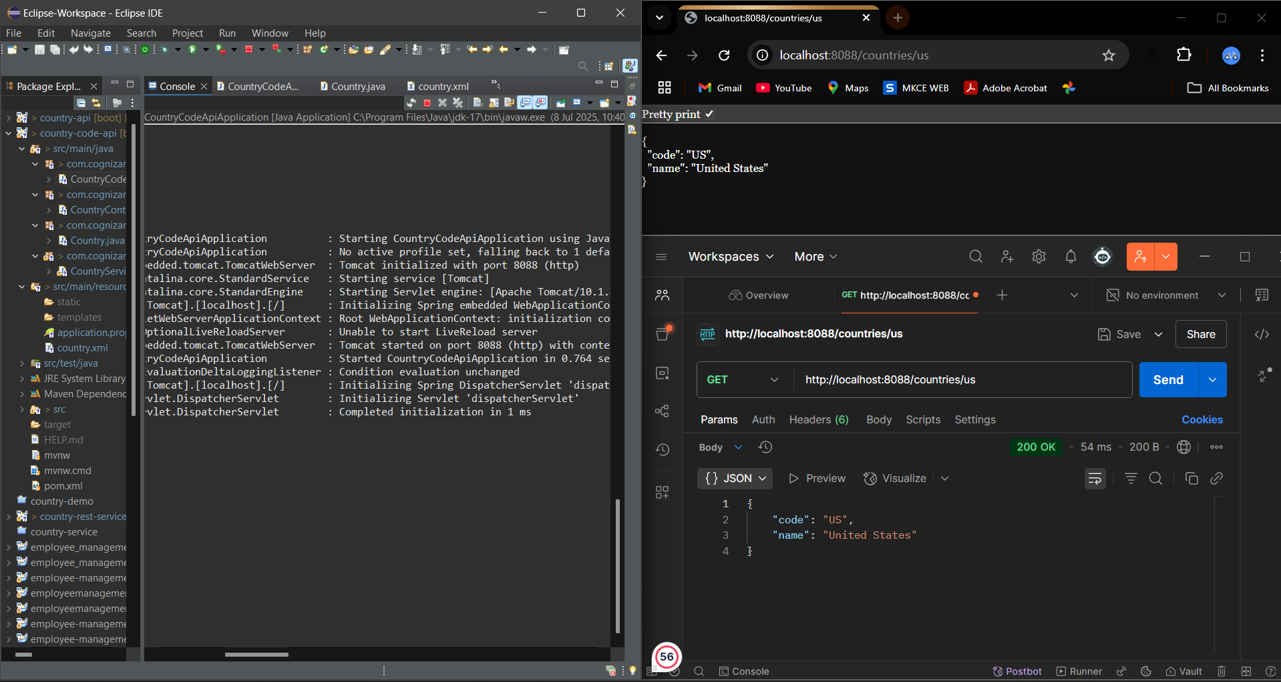
HandsOn_6. REST - Get country exceptional scenario
CountryController.java
package com.cognizant.country_api_exception.controller;

import com.cognizant.country_api_exception.model.Country;
import com.cognizant.country_api_exception.service.CountryService;
import com.cognizant.country_api_exception.exception.CountryNotFoundException;
import org.springframework.beans.factory.annotation.Autowired;
import org.springframework.web.bind.annotation.*;

@RestController
public class CountryController {

@Autowired
private CountryService countryService;

@GetMapping("/country/{code}")
public Country getCountry(@PathVariable String code) throws CountryNotFoundException {
return countryService.getCountry(code);
}
}
CountryNotFoundException.java
package com.cognizant.country_api_exception.exception;

import org.springframework.http.HttpStatus;
import org.springframework.web.bind.annotation.ResponseStatus;

@ResponseStatus(value = HttpStatus.NOT_FOUND, reason = "Country not found")
public class CountryNotFoundException extends Exception {
public CountryNotFoundException(String message) {
super(message);
}
}
Country.java
package com.cognizant.country_api_exception.model;

public class Country {
private String code;
private String name;

public Country() {}

public Country(String code, String name) {
this.code = code;
this.name = name;
}

public String getCode() {
return code;
}

public void setCode(String code) {
this.code = code;
}

public String getName() {
return name;
}

public void setName(String name) {
this.name = name;
}
}
CountryService.java
package com.cognizant.country_api_exception.service;

import com.cognizant.country_api_exception.model.Country;
import com.cognizant.country_api_exception.exception.CountryNotFoundException;
import org.springframework.beans.factory.annotation.Autowired;
import org.springframework.context.ApplicationContext;
import org.springframework.stereotype.Service;
import java.util.List;

@Service
public class CountryService {

@Autowired
private ApplicationContext context;

public Country getCountry(String code) throws CountryNotFoundException {
List<Country> countries = (List<Country>) context.getBean("countryList");

return countries.stream()
.filter(country -> country.getCode().equalsIgnoreCase(code))
.findFirst()
.orElseThrow(() -> new CountryNotFoundException("Country not found"));
}
}
CountryApiExceptionApplication.java
package com.cognizant.country_api_exception;

import org.springframework.boot.SpringApplication;
import org.springframework.boot.autoconfigure.SpringBootApplication;
import org.springframework.context.annotation.ImportResource;

@SpringBootApplication
@ImportResource("classpath:country.xml") // Load bean config from XML
public class CountryApiExceptionApplication {
public static void main(String[] args) {
SpringApplication.run(CountryApiExceptionApplication.class, args);
}
}
application.properties
spring.application.name=country-api-exception
server.port=8088
country.xml
<?xml version="1.0" encoding="UTF-8"?>
<beans xmlns="http://www.springframework.org/schema/beans"
xmlns:xsi="http://www.w3.org/2001/XMLSchema-instance"
xsi:schemaLocation="
http://www.springframework.org/schema/beans
https://www.springframework.org/schema/beans/spring-beans.xsd">

<!-- Individual Country Bean -->
<bean id="country" class="com.cognizant.country_api_exception.model.Country">
<property name="code" value="IN"/>
<property name="name" value="India"/>
</bean>

<!-- List of Countries -->
<bean id="countryList" class="java.util.ArrayList">
<constructor-arg>
<list>
<bean class="com.cognizant.country_api_exception.model.Country">
<property name="code" value="IN"/>
<property name="name" value="India"/>
</bean>
<bean class="com.cognizant.country_api_exception.model.Country">
<property name="code" value="US"/>
<property name="name" value="United States"/>
</bean>
<bean class="com.cognizant.country_api_exception.model.Country">
<property name="code" value="JP"/>
<property name="name" value="Japan"/>
</bean>
<bean class="com.cognizant.country_api_exception.model.Country">
<property name="code" value="DE"/>
<property name="name" value="Germany"/>
</bean>
</list>
</constructor-arg>
</bean>
</beans>
CodeApplicationTests.java
package com.cognizant.country_api_exception;

import org.junit.jupiter.api.Test;
import org.springframework.boot.test.context.SpringBootTest;

@SpringBootTest
class CodeApplicationTests {

@Test
void contextLoads() {
}

}

OUTPUT
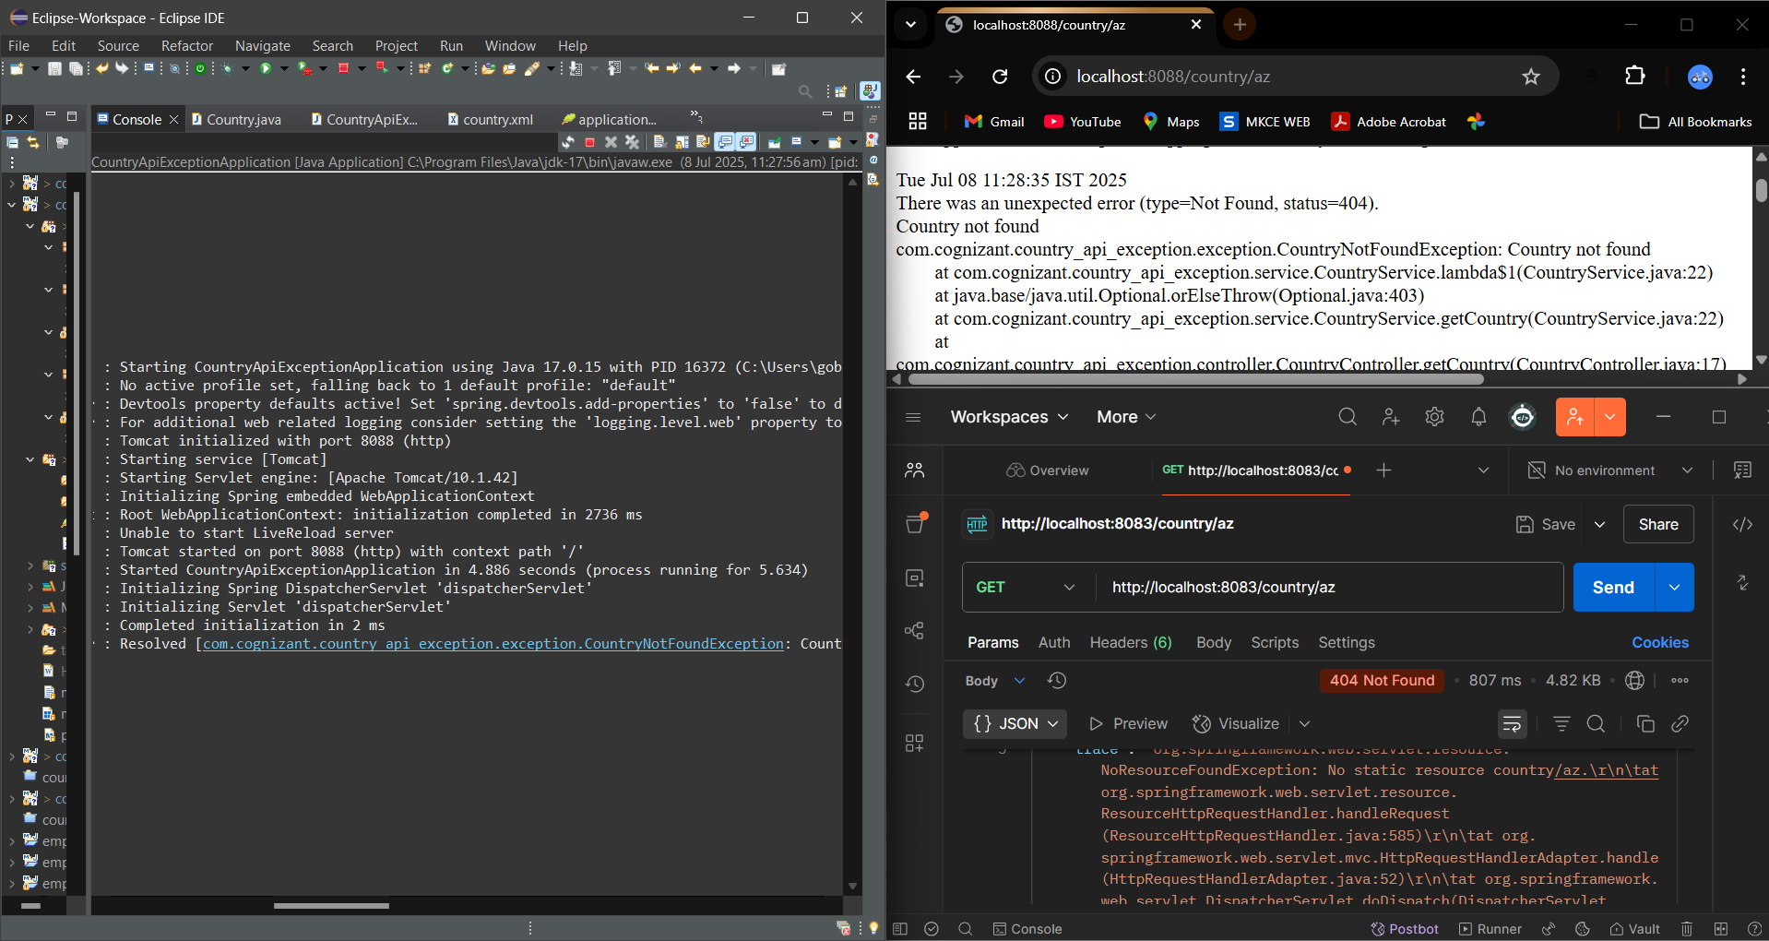

HandsOn_7. MockMVC - Test get country service
CountryController.java
package com.cognizant.mockmvc_country_api.controller;

import com.cognizant.mockmvc_country_api.model.Country;
import org.springframework.beans.factory.annotation.Autowired;
import org.springframework.context.ApplicationContext;
import org.springframework.web.bind.annotation.RequestMapping;
import org.springframework.web.bind.annotation.RestController;

@RestController
public class CountryController {

@Autowired
private ApplicationContext context;

public CountryController() {
System.out.println("CountryController initialized.");
}

@RequestMapping("/country")
public Country getCountryIndia() {
return (Country) context.getBean("country");
}
}
Country.java
package com.cognizant.mockmvc_country_api.model;

public class Country {
private String code;
private String name;

public Country() {
}

public Country(String code, String name) {
this.code = code;
this.name = name;
}

public String getCode() {
return code;
}

public void setCode(String code) {
this.code = code;
}

public String getName() {
return name;
}

public void setName(String name) {
this.name = name;
}
}
MockmvcCountryApiApplication.java
package com.cognizant.mockmvc_country_api;

import org.springframework.boot.SpringApplication;
import org.springframework.boot.autoconfigure.SpringBootApplication;
import org.springframework.context.annotation.ImportResource;

@SpringBootApplication
@ImportResource("classpath:country.xml")
public class MockmvcCountryApiApplication {

public static void main(String[] args) {
SpringApplication.run(MockmvcCountryApiApplication.class, args);
}
}

application.properties
spring.application.name=code
country.xml
<?xml version="1.0" encoding="UTF-8"?>
<beans xmlns="http://www.springframework.org/schema/beans"
xmlns:xsi="http://www.w3.org/2001/XMLSchema-instance"
xsi:schemaLocation="
http://www.springframework.org/schema/beans
https://www.springframework.org/schema/beans/spring-beans.xsd">

<bean id="country" class="com.cognizant.mockmvc_country_api.model.Country">
<property name="code" value="IN"/>
<property name="name" value="India"/>
</bean>
</beans>
MockmvcCountryApiApplicationTests.java
package com.cognizant.mockmvc_country_api;

import com.cognizant.mockmvc_country_api.controller.CountryController;
import org.junit.jupiter.api.Test;
import org.springframework.beans.factory.annotation.Autowired;
import org.springframework.boot.test.context.SpringBootTest;
import org.springframework.test.web.servlet.MockMvc;
import org.springframework.boot.test.autoconfigure.web.servlet.AutoConfigureMockMvc;

import static org.junit.jupiter.api.Assertions.assertNotNull;
import static org.springframework.test.web.servlet.request.MockMvcRequestBuilders.get;
import static org.springframework.test.web.servlet.result.MockMvcResultMatchers.*;

@SpringBootTest
@AutoConfigureMockMvc
public class MockmvcCountryApiApplicationTests {

@Autowired
private CountryController countryController;

@Autowired
private MockMvc mvc;

@Test
public void contextLoads() {
assertNotNull(countryController);
}

@Test
public void testGetCountry() throws Exception {
mvc.perform(get("/country"))
.andExpect(status().isOk())
.andExpect(jsonPath("$.code").exists())
.andExpect(jsonPath("$.code").value("IN"))
.andExpect(jsonPath("$.name").exists())
.andExpect(jsonPath("$.name").value("India"));
}
}

OUTPUT
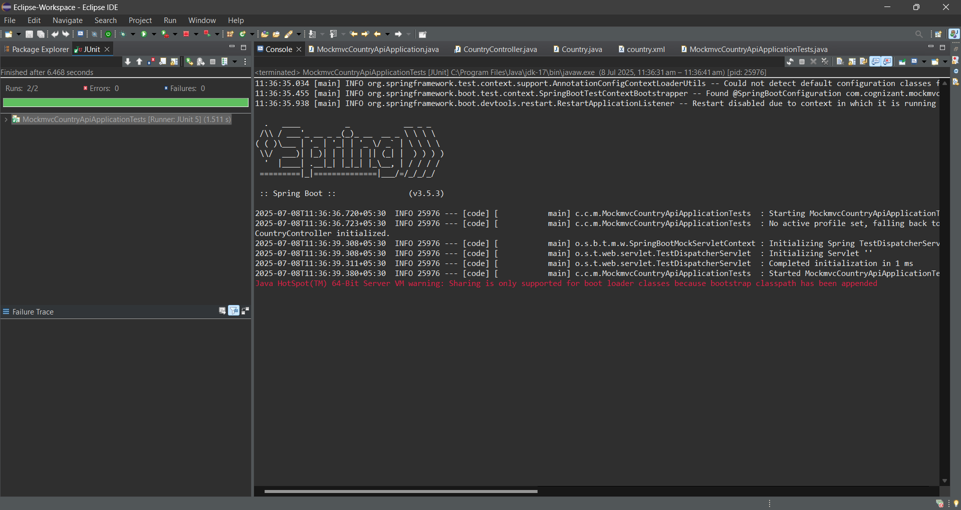
HandsOn_8. MockMVC - Test get country service for exceptional scenario
CountryController.java
package com.cognizant.country_api_mockmvc_exception.controller;

import com.cognizant.country_api_mockmvc_exception.model.Country;
import com.cognizant.country_api_mockmvc_exception.service.CountryService;
import org.springframework.beans.factory.annotation.Autowired;
import org.springframework.web.bind.annotation.*;

@RestController
public class CountryController {

@Autowired
private CountryService service;

@GetMapping("/country/{code}")
public Country getCountry(@PathVariable String code) {
return service.getCountry(code);
}
}

Country.java
package com.cognizant.country_api_mockmvc_exception.model;

public class Country {
private String code;
private String name;

public Country() {
}

public Country(String code, String name) {
this.code = code;
this.name = name;
}

public String getCode() {
return code;
}

public void setCode(String code) {
this.code = code;
}

public String getName() {
return name;
}

public void setName(String name) {
this.name = name;
}

// Optional: toString method for debugging
@Override
public String toString() {
return "Country{" +
"code='" + code + '\'' +
", name='" + name + '\'' +
'}';
}
}
CountryNotFoundException.java
package com.cognizant.country_api_mockmvc_exception.service.exception;

import org.springframework.http.HttpStatus;
import org.springframework.web.bind.annotation.ResponseStatus;

@ResponseStatus(value = HttpStatus.BAD_REQUEST, reason = "Country Notfound")
public class CountryNotFoundException extends RuntimeException {
public CountryNotFoundException(String message) {
super(message);
}
}
CountryService.java
package com.cognizant.country_api_mockmvc_exception.service;

import com.cognizant.country_api_mockmvc_exception.model.Country;
import com.cognizant.country_api_mockmvc_exception.service.exception.CountryNotFoundException;
import org.springframework.context.ApplicationContext;
import org.springframework.context.support.ClassPathXmlApplicationContext;
import org.springframework.stereotype.Service;

import java.util.List;

@Service
public class CountryService {

public Country getCountry(String code) throws CountryNotFoundException {
ApplicationContext context = new ClassPathXmlApplicationContext("country.xml");

@SuppressWarnings("unchecked")
List<Country> countries = (List<Country>) context.getBean("countryList");

return countries.stream()
.filter(country -> country.getCode().equalsIgnoreCase(code))
.findFirst()
.orElseThrow(() -> new CountryNotFoundException("Country Notfound"));
}
}
CountryApiMockmvcExceptionApplication.java
package com.cognizant.country_api_mockmvc_exception;

import org.springframework.boot.SpringApplication;
import org.springframework.boot.autoconfigure.SpringBootApplication;
import org.springframework.context.annotation.ImportResource;

@SpringBootApplication
@ImportResource("classpath:country.xml")
public class CountryApiMockmvcExceptionApplication {
public static void main(String[] args) {
SpringApplication.run(CountryApiMockmvcExceptionApplication.class, args);
}
}
application.properties
spring.application.name=code
server.port=8083
#spring.config.import=optional:classpath:country.xml
country.xml
<?xml version="1.0" encoding="UTF-8"?>
<beans xmlns="http://www.springframework.org/schema/beans"
xmlns:xsi="http://www.w3.org/2001/XMLSchema-instance"
xsi:schemaLocation="http://www.springframework.org/schema/beans
https://www.springframework.org/schema/beans/spring-beans.xsd">

<bean id="country" class="com.cognizant.country_api_mockmvc_exception.model.Country">
<property name="code" value="IN"/>
<property name="name" value="India"/>
</bean>

<bean id="countryList" class="java.util.ArrayList">
<constructor-arg>
<list>
<ref bean="country"/>
<bean class="com.cognizant.country_api_mockmvc_exception.model.Country">
<property name="code" value="US"/>
<property name="name" value="United States"/>
</bean>
<bean class="com.cognizant.country_api_mockmvc_exception.model.Country">
<property name="code" value="JP"/>
<property name="name" value="Japan"/>
</bean>
<bean class="com.cognizant.country_api_mockmvc_exception.model.Country">
<property name="code" value="DE"/>
<property name="name" value="Germany"/>
</bean>
</list>
</constructor-arg>
</bean>

</beans>
CountryApiMockmvcExceptionApplicationTests.java
package com.cognizant.country_api_mockmvc_exception;

import com.cognizant.country_api_mockmvc_exception.controller.CountryController;
import org.junit.jupiter.api.Test;
import org.springframework.beans.factory.annotation.Autowired;
import org.springframework.boot.test.context.SpringBootTest;
import org.springframework.boot.test.autoconfigure.web.servlet.AutoConfigureMockMvc;
import org.springframework.test.web.servlet.MockMvc;
import org.springframework.test.web.servlet.ResultActions;
import static org.junit.jupiter.api.Assertions.assertNotNull;
import static org.springframework.test.web.servlet.request.MockMvcRequestBuilders.get;
import static org.springframework.test.web.servlet.result.MockMvcResultMatchers.status;
@SpringBootTest
@AutoConfigureMockMvc
public class CountryApiMockmvcExceptionApplicationTests {
@Autowired
private CountryController countryController;
@Autowired
private MockMvc mvc;
@Test
public void contextLoads() {
assertNotNull(countryController);
}
@Test
public void testGetCountryException() throws Exception {
ResultActions actions = mvc.perform(get("/country/az")); // not present
actions.andExpect(status().isBadRequest());
actions.andExpect(status().reason("Country Notfound"));
}
}
OUTPUT
